**Céin O’Rourke**

**C14427818**

**Operating Systems**

**Assignment**

**and Labs**

**Course Code**

**DT282**

**Year 1**

**Course Title**

**Operating Systems 1**

**Table of Contents**

OPERATING SYSTEMS 1 LABS 3

Lab #1 4

Lab #2 5

Lab #3 6

Lab #4 7

OPERATING SYSTEMS 1 ASSIGNMENTS 8

Assignmment #1 9

# OPERATING SYSTEMS 1 LABS

## Lab #1

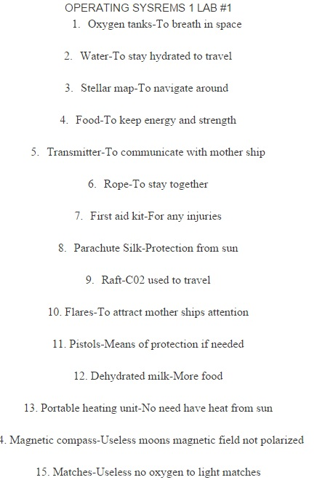

## Lab #2

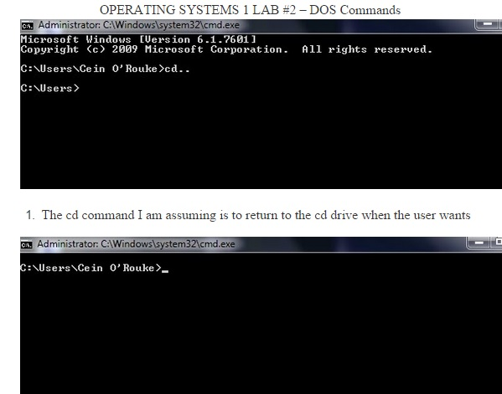

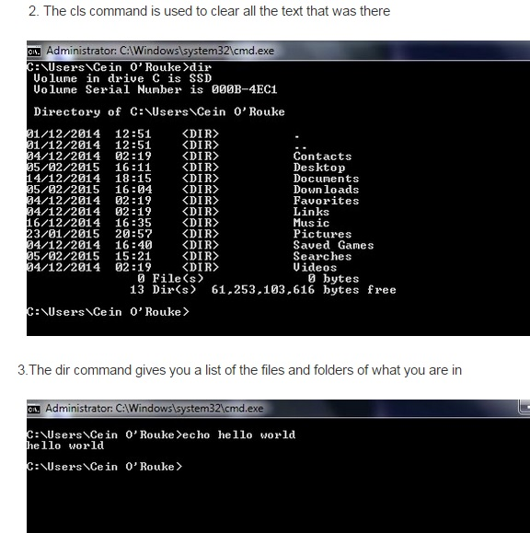

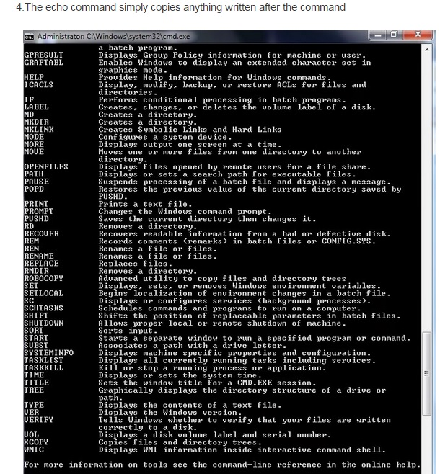

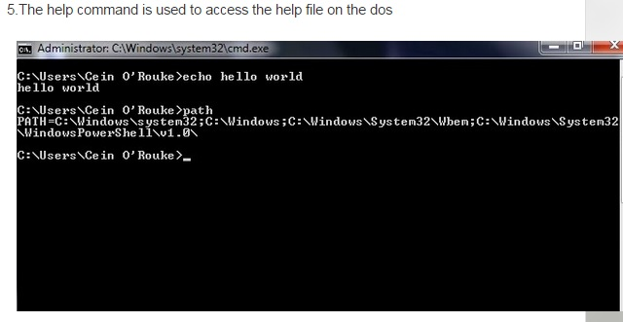

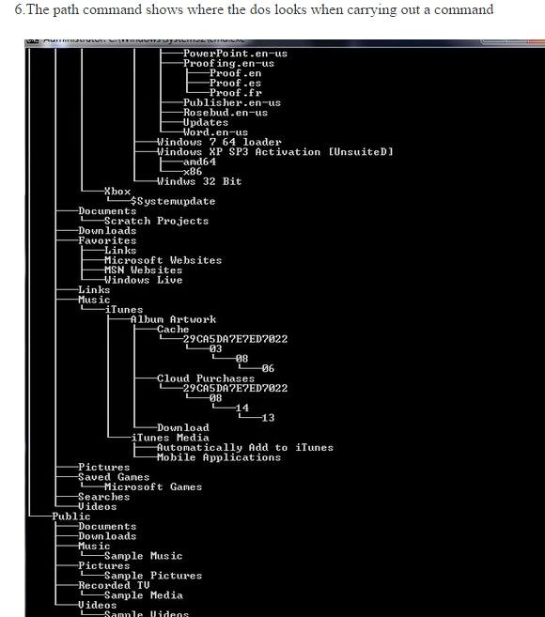

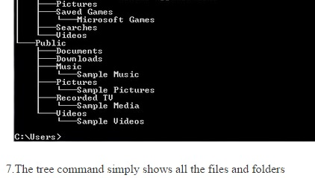

## Lab #3

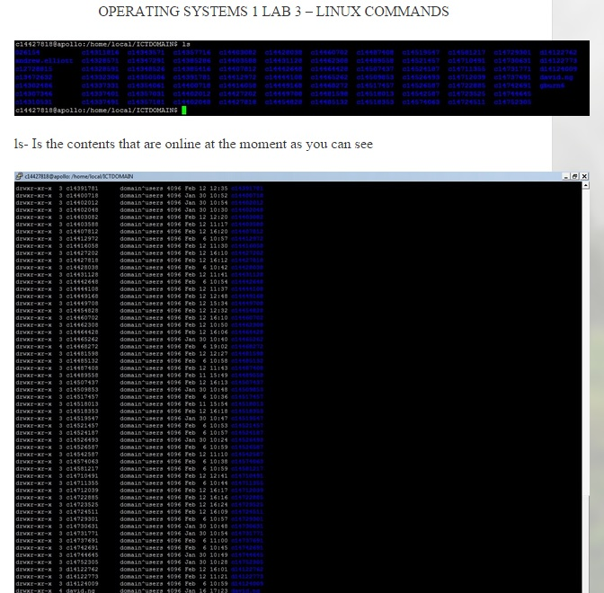

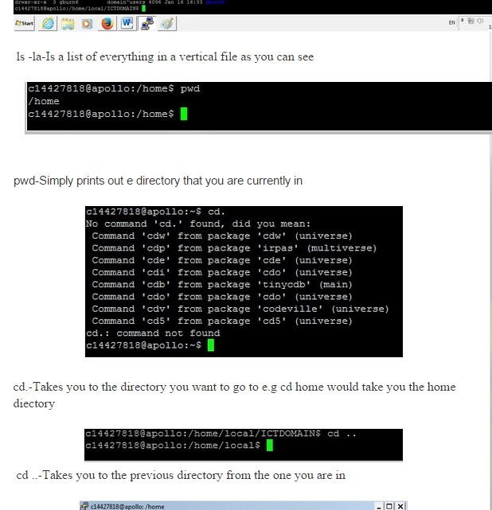

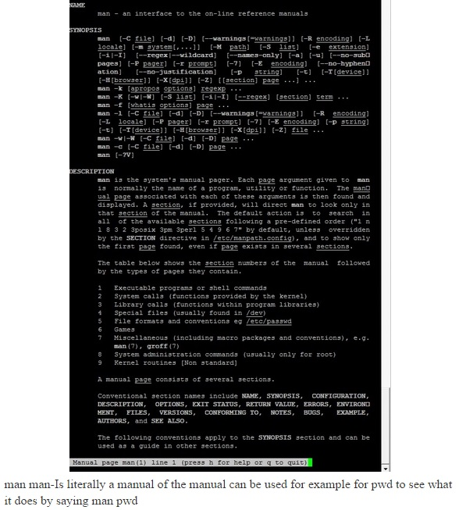

## Lab #4

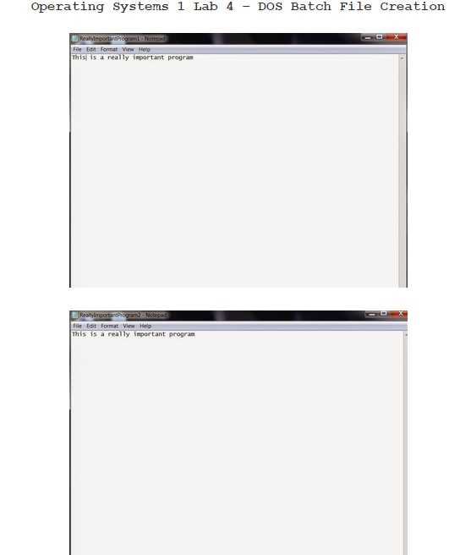

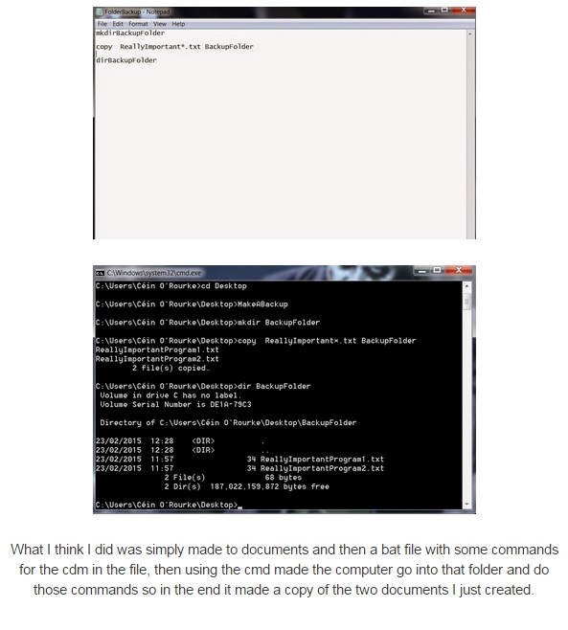

# OPERATING SYSTEMS 1 ASSIGNMENTS

|  |  |  |  |  |  |  |
| --- | --- | --- | --- | --- | --- | --- |
| **1.** | | **(a)** | | Write a DOS Batch script to automatically recursively backup files from a specified directory (and all its sub-directories), to a newly create directory called BackupFolder (with the same sub-directories). Finally list all the files recursively in the new BackupFolder.  Provide screengrabs of the script file, a directory listing before you run the script, a directory listing after you run the script, and at least 150 words explaining how you figured out how to make this work, and what each command does.  bat | | |
|  | |  | | dir  folder1  copying  copied  I learned how to do this by looking around on the internet for a while and then I came across the xcopy command. I then looked on youtube on tutorials showing me how to get this working and failed a few times and then learned that I had to have the /s/e at the end of what I wanted to copy to make it work. What I am doing with the commands is making a backupfolder and copying the files the folder I made and the folder itself into the backup folder. | | |
| 1. | | (b) | | Write a Bash/Linux script to automatically recursively backup files from a specified directory (and all its sub-directories), to a newly create directory called BackupFolder (with the same sub-directories). Finally list all the files recursively in the new BackupFolder, and what each command does.  Provide screengrabs of the script file, a directory listing before you run the script, a directory listing after you run the script, and at least 150 words explaining how you figured out how to make this work.  sh file  yep  copying  copied  Again I used the internet for the commands to use this and then also with the lab work that we were given was also very helpful. After I used youtube again for tutorial on how to execute what I wanted to do. It took me a while to get the right command for it to work but then I used the sh~ command and it worked. What the commands did again was make a backup folder and copied the folder I made and the contents that were inside the folder. (the OS folder is just the screenshots I took if it looks confusing). | | |
| **1.** | **(c)** | | The Little Man model uses a single-digit op-code and a 2-digit memory addressing and has the following instructions defined where the address portion is shown as xx | |  |

|  |  |  |
| --- | --- | --- |
| **OpCode** | **Instruction** | **Description** |
| 1xx | ADD | Add the value of a given memory location to calculator |
| 2xx | SUBTRACT | Subtract the value of a given memory location to calculator |
| 3xx | STORE | Copy the value from the calculator into a given memory location |
| 5xx | LOAD | Copy the value from a given memory location into the calculator |
| 6xx | BRANCH | Unconditional branch. Set the Program Counter to value xx |
| 7xx | BRANCH IF ZERO | Conditional branch. If the accumulator is zero, branch to xx |
| 8xx | BRANCH IF POSITIVE | Conditional branch. If the accumulator is positive, branch to xx |
| 901 | INPUT | Get the value from the IN-TRAY and put it into the calculator |
| 902 | OUTPUT | Put the value in the calculator into the OUT-TRAY |
| 000 | HALT | Take a break |

|  |  |  |  |  |  |  |  |  |  |  |  |  |  |  |  |  |  |  |  |
| --- | --- | --- | --- | --- | --- | --- | --- | --- | --- | --- | --- | --- | --- | --- | --- | --- | --- | --- | --- |
|  |  | Write a program using these codes to take two numbers which are contained in the IN-TRAY and display the sum (+) of those numbers in the OUT-TRAY. Comment every instruction   |  |  | | --- | --- | | 901 | Read in first number | | 308 | Store first number in slot 8 | | 901 | Read in second number | | 309 | Store second number in slot 9 | | 508 | Load the first number | | 109 | Add to first number to second number | | 902 | Put the answer in out-tray | | 000 | Stop | |  |

## Assignmment #1

### Group Reflections

The font, spacing, etc. should match this text.

This section is the two-page Word document documenting your journey, including a

**List of the Group Members**

* Céin O’Rourke
* Jordan Forde
* Andrew Leech
* Éanna Brennan
* Daniel Tilley

**Groupname**

*The D.I.T Avengers*

**Roles and Responsibilities of Group Members**

* Daniel Tilley – Group leader, Presenter, Documenter, Researcher and did 4 slides
* Céin O’Rourke – Researcher, Documenter, also Presenter and did 4 slides
* Andrew Leech – designer of PowerPoint, Documenter, Researcher, Presenter and did 4 slides
* Éanna Brennan – Documenter, Researcher, Presenter and did 4 slides
* Jordan Forde – Documenter, Researcher, Presenter and did 4 slides
* We all did 20% of the work evenly and fairly

**Frequency of Meetings**

A total of 6 meetings, on the following dates and times

* March 4th 10:30 am
* March 12th 4:00 pm
* March 19th 11:00 am
* March 26th 12:00 pm
* April 14th 10:00 am
* Multiple meetings through face book and used most of the labs as meetings aswell

**Decision Making**

No formal decision making process was adhered to, we agreed well as a group.

We put all our ideas together and chose the ones that best suit everyone

**Timescales**

Started – 4/3/2015

Research – From 11/3/2015 to 14/4/2015

Powerpoint – 19/3/2015-14/4/2015

Completed – 14/4/2015

**Resources Used**

* <http://marvel.com/universe/Iron_Man_%28Anthony_Stark%29>
* <http://ironman.wikia.com/wiki/J.A.R.V.I.S>.
* <http://marvel-movies.wikia.com/wiki/J.A.R.V.I.S>.
* <http://en.wikipedia.org/wiki/Edwin_Jarvis>

**What work each other person in your group did.**

* Daniel Tilley – Group leader, Presenter, Documenter, Researcher and did 4 slides (20%)
* Céin O’Rourke – Researcher, Documenter, also Presenter and did 4 slides (20%)
* Andrew Leech – designer of PowerPoint, Documenter, Researcher, Presenter and did 4 slides (20%)
* Éanna Brennan – Documenter, Researcher, Presenter and did 4 slides (20%)
* Jordan Forde – Documenter, Researcher, Presenter and did 4 slides (20%)

### PowerPoint Presentation

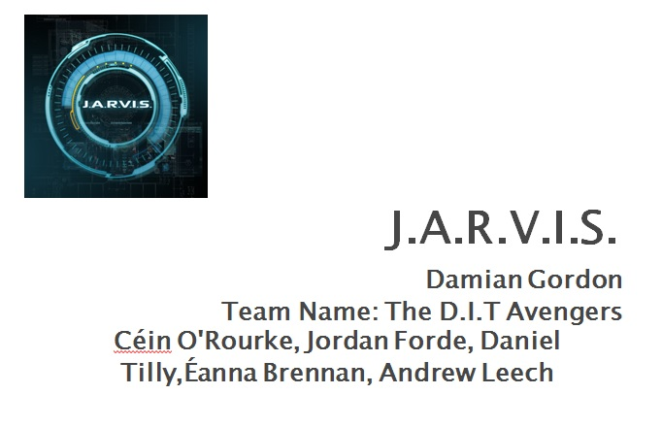

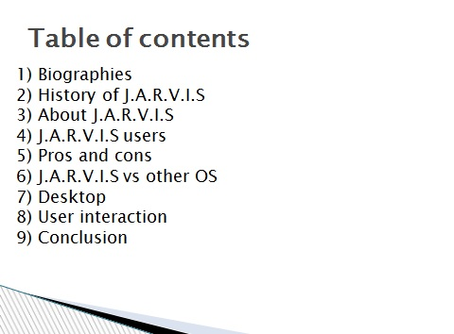

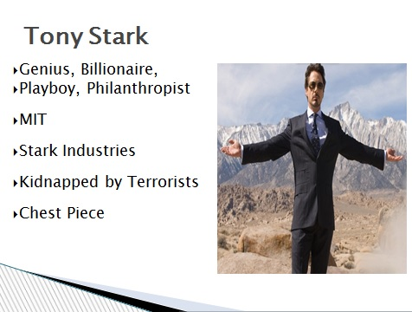

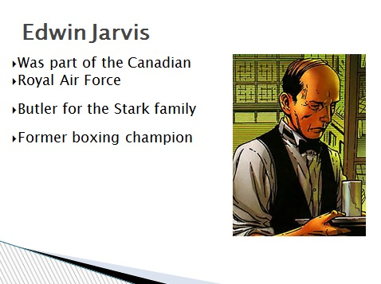

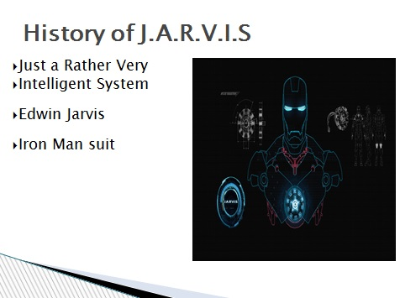

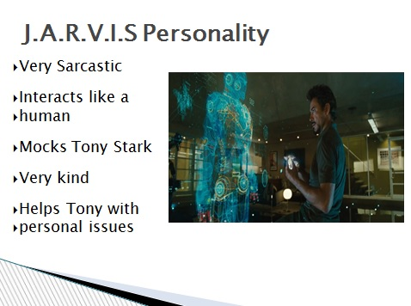

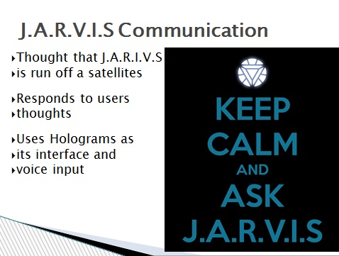

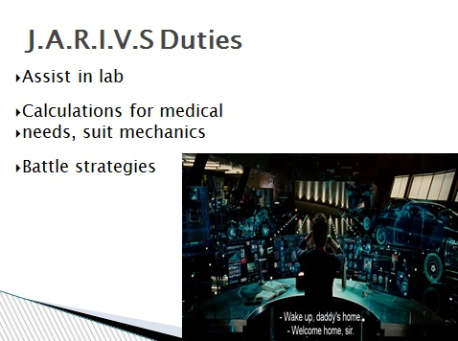

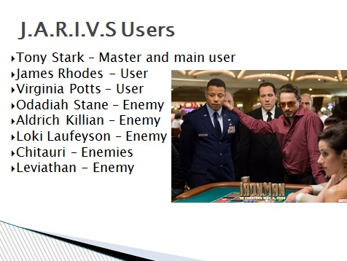

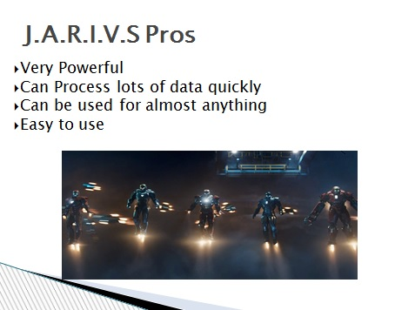

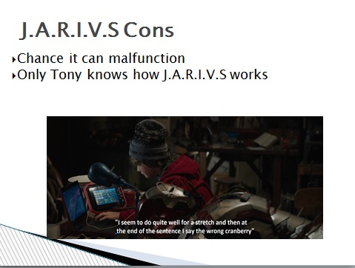

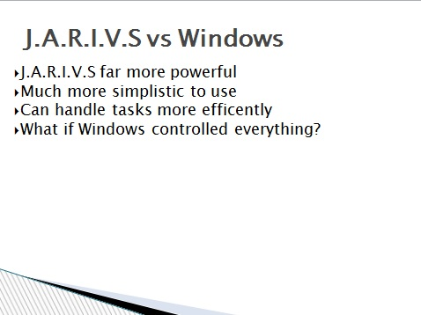

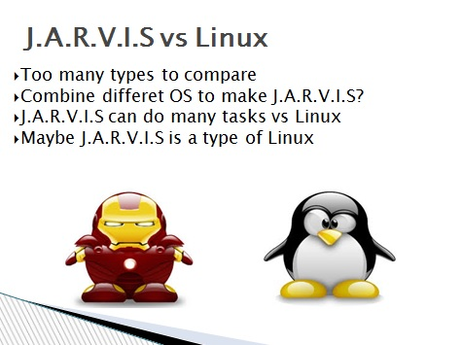

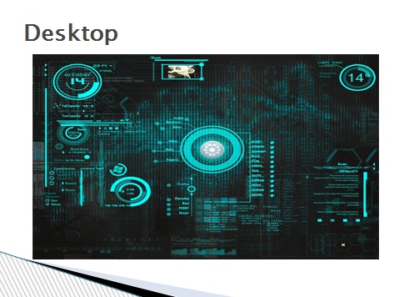

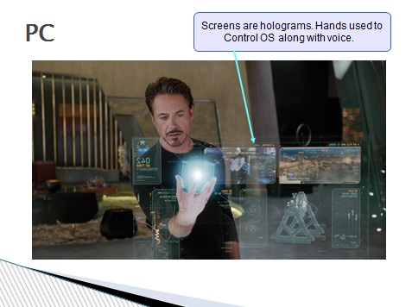

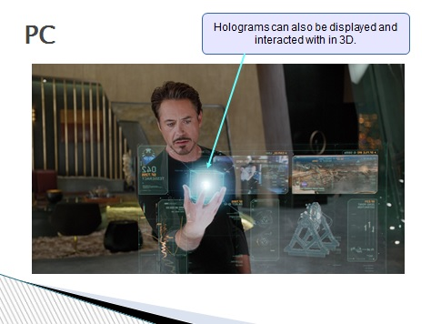

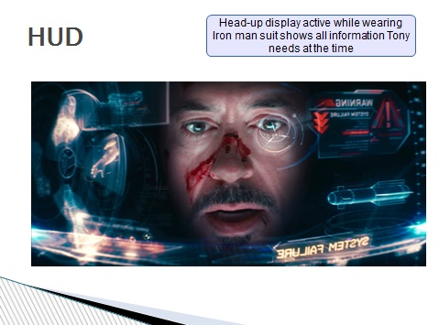

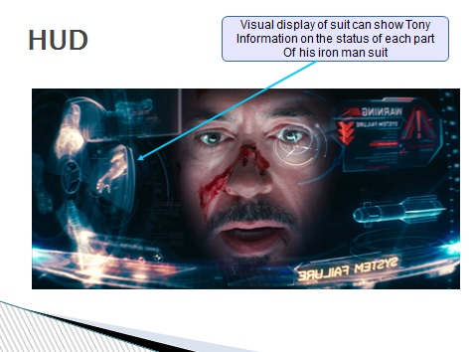

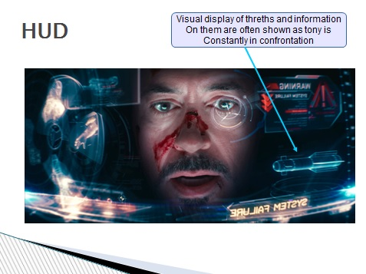

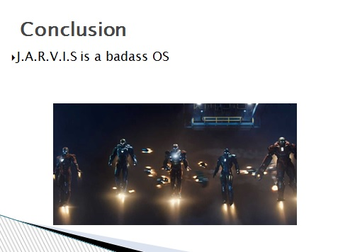

# Reflection

Group Name: The D.I.T Avengers

Members: Céin O’Rourke, Jordan Forde, Andrew Leech, Daniel Tilley, Éanna Brennan

My team and I began our journey together on March 4th after we had been put into a team and given our operating system to work on. At first we were given the operating system Visi On which none of us had ever heard of before. Damian kindly gave the next lab we had to get together with our group and brainstorm. We sat down together not knowing each other at first but get along after a while and then settled down to look at Visi On. To say the least it was a very boring website, so we looked through the other operating systems to choose from and decided that J.A.R.V.I.S was an awesome operating systems and were really looking forward to watching the Iron Man films and the Avengers as study. Soon after we got the e-mail confirming that we had our operating system we jumped straight to it.

Éanna created a Facebook group so we could contact everyone simply and quickly which was a huge help in most cases. We soon met up after our algorithm design lecture and began brainstorming about the presentation and who would do what slides I offered to get us started and began making my four slides. I created a great slide with the iron man chest plate as the background and then doing my research on J.A.R.V.I.S and its main user Tony Stark.

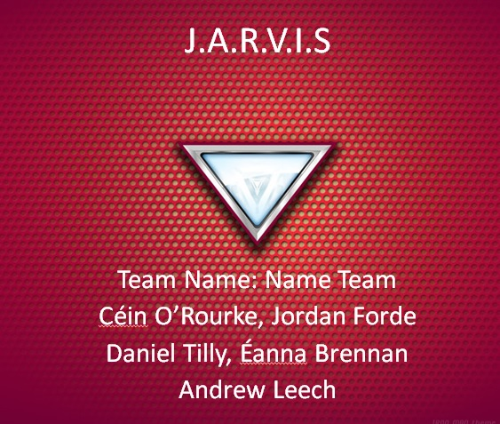

I sent my idea to the Facebook page and we all agreed to go along with this plan, unfortunately we did not see that there was already a template that we had to use as our presentation. After this we mainly used our group chat to make decisions and once everyone agreed with an idea we went ahead and carried out the task, it was very quick and efficient and worked well so that everyone was included not just one or two people doing the work. We didn’t really have time scales just got in contact asking when we thought we should get our individual work done and got the work done. We all worked on the presentation at first we did not really know who was doing what and when we got together and threw ideas down we ended up with some brilliant slides. When I began learning about the background I was really intrigued I never knew that J.A.R.V.I.S was actually based on a butler for the Stark family and it was really interesting doing research about Tony too learning about how he” at the age of 15 Tony entered the undergraduate electrical engineering program at the Massachusetts Institute of Technology (MIT), and graduated with two master’s degrees by age 19”(1). Also how” at the age of 21, Tony inherited Stark Enterprises when his parents were killed in a car accident”(2). I did the biography of Tony and Jarvis for the presentation and the general background of Iron man like when Tony” met Professor Ho Yinsen, They shared a cell and created a magnetic field generator to keep the shrapnel from reaching Tony’s heart and this lead to the first iron man armour being built”(3). Daniel the team leader did the pros and cons and then cleverly compared it to the operating systems Windows and Linux. Jordan did his slides on the users and how J.A.R.V.I.S generally works. Andrew did more of an inside look at the actual architecture of the operating system. Éanna did the conclusion and help make our presentation look the part with some brilliant pictures. To help us get information we watched the movies and looked up the websites

• http://marvel.com/universe/Iron_Man_%28Anthony_Stark%29

• http://ironman.wikia.com/wiki/J.A.R.V.I.S.

• http://marvel-movies.wikia.com/wiki/J.A.R.V.I.S.

• http://en.wikipedia.org/wiki/Edwin_Jarvis

Also while watching the movies we watched how he interacted with J.A.R.V.I.S in multiple ways and this helped us get a better idea of how to use this operating system and how it is used. We all pulled together as a group so I have no complaints we all split the work and it was a great assignment to do on a superhero’s operating system and watching movies was our study, everybody did a fair 20% and when we got together everyone put forward ideas and everybody’s ideas were taken into consideration and no one was looked at as more important than someone else. We could not decide a team name straight away we had so many options we had Iron Men, Name Team and so many other names were offered. We eventually just decided to go with The D.I.T Avengers it’s relevant to the assignment and the operating system and it is quite catchy. Overall assignment was very enjoyable and was a good experience to work with a group of people I did not know before and produce so much.

# References

1. Marvel () Iron Man(Anthony Stark), Available at: http://marvel.com/universe/Iron_Man_%28Anthony_Stark%29 (Accessed: 19th March 2015).
2. Marvel () Iron Man(Anthony Stark), Available at: http://marvel.com/universe/Iron_Man_%28Anthony_Stark%29 (Accessed: 19th March 2015).
3. Marvel () Iron Man(Anthony Stark), Available at: http://marvel.com/universe/Iron_Man_%28Anthony_Stark%29 (Accessed: 19th March 2015).